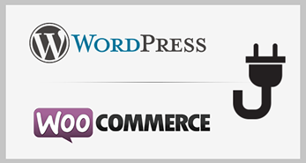Instruction for installation payment plugin **eCommerceConnect** for the system Wordpress (Woocommerce)

1. At first, you have to check if the system of electronic-commerce WooCommerce is installed at your CMS WordPress.

If the WooCommerce does not install you, have to add it.

**Plugins → Search Plugins (WooCommerce) → Install Now**

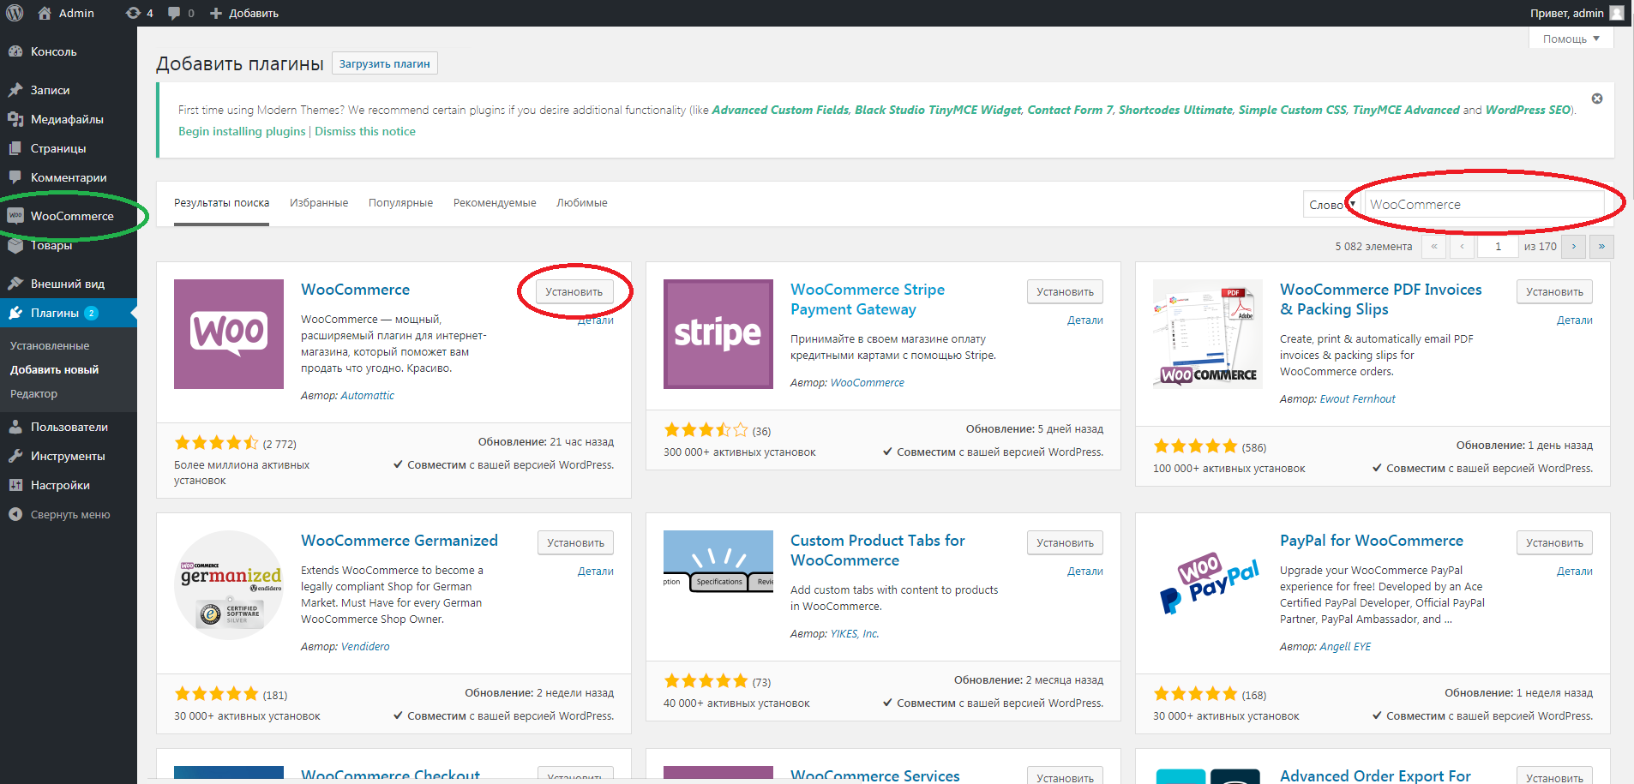

When the WooCommerce plugin installed successfully there is, will be new section (WooCommerce) in the main menu of WordPress.

1. Installation of eCommerceConnect plugin.

In the section **Plugins** you need push the button **Upload Plugin** and choose *ecc_woocommerce.zip* file that specialists from UPC will send to you in the email. After that push button **Install Now**.

This file is already ready to use and it is with all configurations you need.

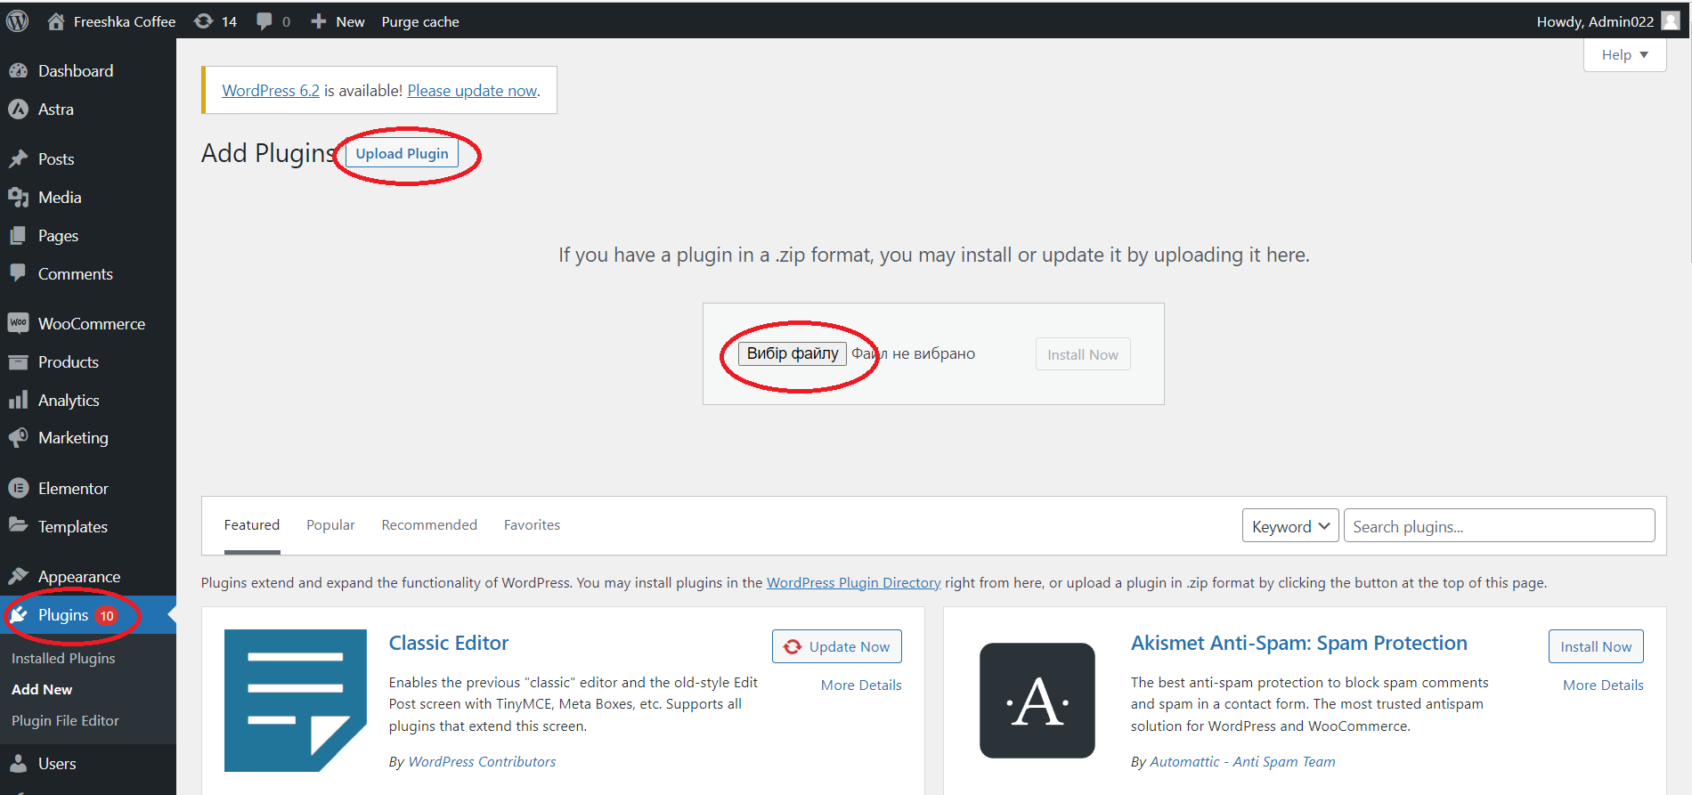

After successful installation, you will see this plugin in section **Installed Plugins**

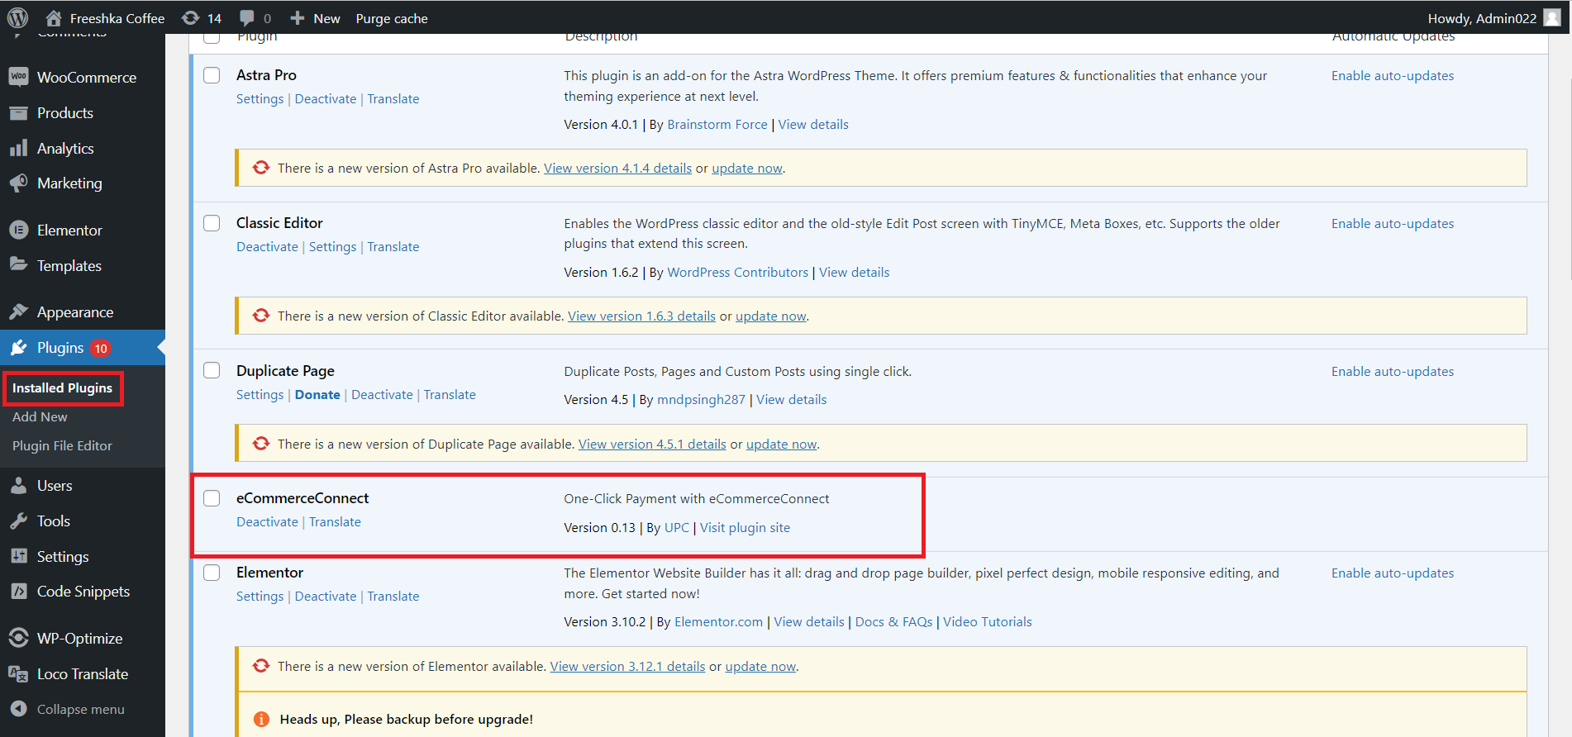

1. Now you have to make some eCommerceConnect plugin settings.

You have to move to the section Settings

**WooCommerce → Settings → Payments**

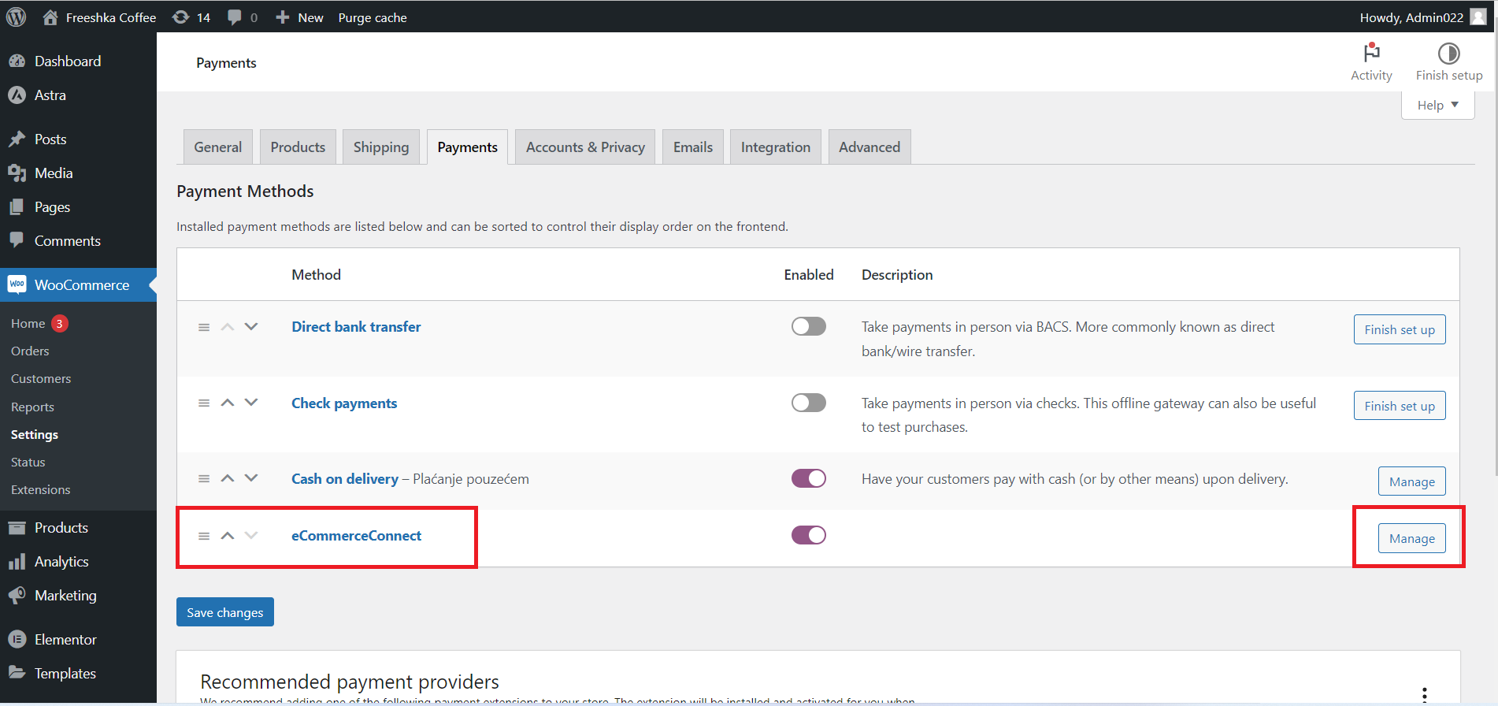

Find eCommerceConnect and push the button **Manage.**

Than you will be, see settings menu of eCommerceConnect.

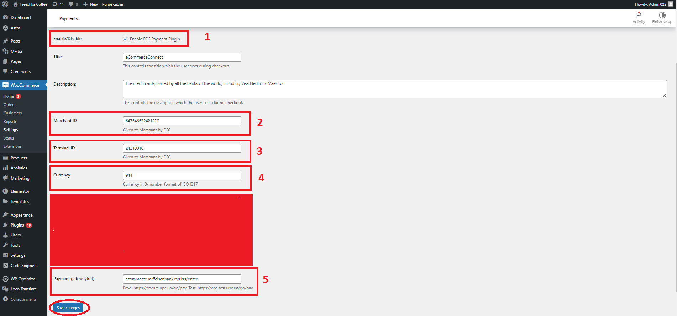

First, you have to enable this plugin. Than set up your **Merchant ID** and **Terminal ID**. This information you will get from UPC specialists.

Also, put in **Currency Code** in international standard format ISO 4217:2015.

EURO – 978

USD – 840

ALL – 008

BAM – 977

RSD – 941

Finally, indicate **Payment Gateway**. This URL you will also get from UPC. And push button **Save Changes**.

4. Callback function settings

In Merchant Interface <https://ecommerce.raiffeisenbank.rs/rbrs/merchant/> (access will be provided by UPC) need to set up Callback-URL

**Terminals → Merchant ID → Notify URL**

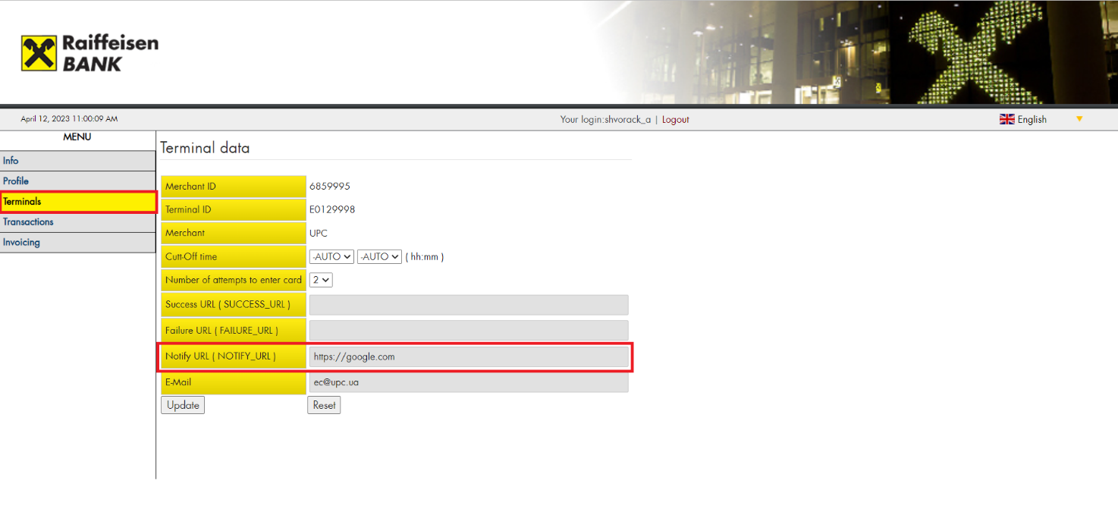

In this field, you have to set up URL in format [**http://my.site.com/wc-api/wc_ecc**](http://my.site.com/wc-api/wc_ecc)where [**http://my.site.com**](http://my.site.com)is a real URL of your store.

1. After all settings to check is everything works correctly, you just need to make test order. And, if you get opened payment page it means that plugin works.

